1. **Agenda:**
   1. Configure min-insync-replicas
2. Two ways
   1. When creating topic.  
        
        
      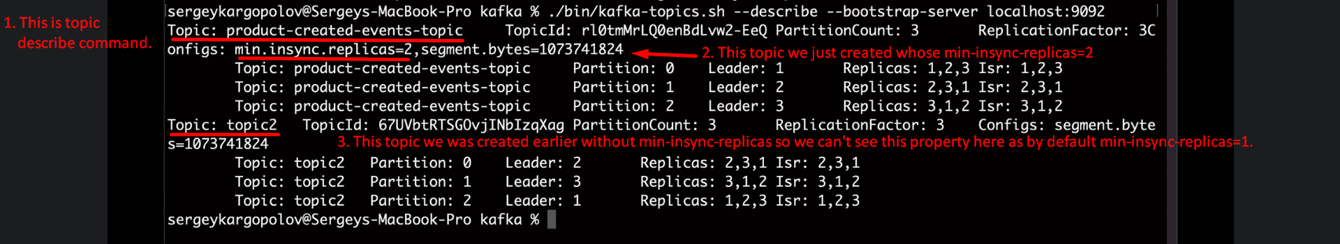
   2. When topic is already created:  
        
        
      